**Lab Report # 08**



**CSE301 - L Signals & Systems Lab**

Submitted by: AWAIS SADDIQUI

Registration No: 21PWCSE1993

Class Section: “A”

Submitted to:

**Dr. Durr-e-Nayab**

**Department of Computer System Engineering**

**UET Peshawar**

**301L: Signals & Systems Lab**

**LAB ASSESSMENT RUBRICS**

|  |  |  |  |  |
| --- | --- | --- | --- | --- |
| **Marking Criteria** | **Exceeds expectation (5-4)** | **Meets expectation** **(3-2)** | **Does not meet expectation (1)** | **Score** |
| **1. Realization of Experiment** | Program compiles (noerrors and no warnings).  Program always works correctly and meets the specification(s).  Completed between 71-100% of the requirements. | Program compiles (no errors and some warnings).  Some details of the program specification are violated, program functions incorrectly for some inputs.  Completed between 41-70% of the requirements. | Program fails to or compile with lots of warnings.  Program only functions correctly in very limited cases or not at all.  Completed less than  40% of the requirements. | 30% |
| **2. Ability to apply required code utility or data structure** | Able to apply required data type or data structure and produce correct results. Familiarize and selects proper functions for simulation of given problem using  software tools like  MATLAB. | Able to apply required data type or data structure but does not produce correct results. Need guidance to select proper functions for simulation of given problem using  software tools like  MATLAB. | Unable to identify required data type or data structure.  Incapable of selecting proper functions for simulation of given problem using software tools like MATLAB. | 20% |
| **3. Documentation** | Clearly and effectively documented including descriptions of all variables/functions. Specific purpose is noted for each function, control structure, input requirements and output results. | Basic documentation including descriptions of all variables/functions. Specific purpose is noted for each function and control structure. | No documentation included. | 10% |
| **4. Ability to run/debug** | Executes Matlab codes without errors, excellent user | Executes Matlab codes without errors.  User prompts are | Does not execute Matlab codes due to errors. | 20% |

|  |  |  |  |  |
| --- | --- | --- | --- | --- |
|  | prompts, good use of symbols, spacing in output.  Thorough and organized testing has been completed and output from test cases is included. | understandable, minimum use of symbols or spacing in output.  Some testing has been completed. | User prompts are misleading or nonexistent.  No testing has been completed. |  |
| **5. Results compilation** | Show processed results effectively by conducting simple computations and plotting using collected data | Show processed results effectively by conducting simple computations and plotting using collected data with minor error | Unable to show processed results effectively by conducting simple computations and plotting using collected data with minor error | 10% |
| **6. Efficiency** | Excellent use of CPU and Memory. | Good but not smart use of CPU and Memory. | Inefficient use of CPU and Memory. | 10% |
| **7. Lab**  **Performance (Team work and Lab**  **etiquettes)** | Actively engages and cooperates with other group members in an effective manner. Respectfully and carefully observes safety rules and procedures | Cooperates with other group members in a reasonable manner. Observes safety rules and procedures with minor deviation. | Distracts or discourages other group members from conducting the experiment. Disregards  safety rules and procedures. | 10% |

**Instructor:**

Name: _________________________

Signature: ______________________

**Signals & Systems Laboratory**

**MAKING SIGNALS CAUSAL AND NON-CAUSAL:**

A causal signal is a signal whose output depends only on the present and past values of the input. A non-causal signal is a signal whose output depends on the future values of the input. Non-causal signals can be useful in some applications, such as prediction and control. However, they cannot be implemented in practice because they require knowledge of the future.

**Causal Signals:**

A signal is said to be causal if it is zero for time t<0. signal can be made causal by multiplying it with unit step.

**OBJECTIVES OF THE LAB**

• Making Signals Causal and Non‐Causal

• Convolution

• Properties of Convolution

**TASK 01**

**CODE:**

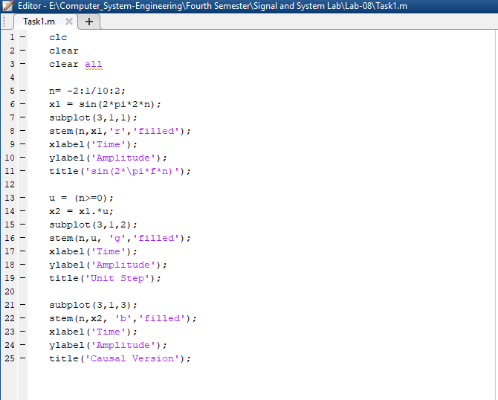

**OUPUT:**

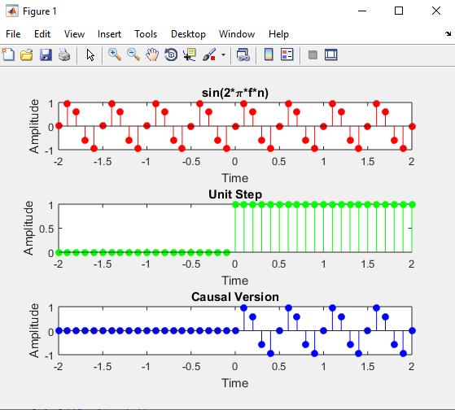

**TASK 02:**

**CODE:**

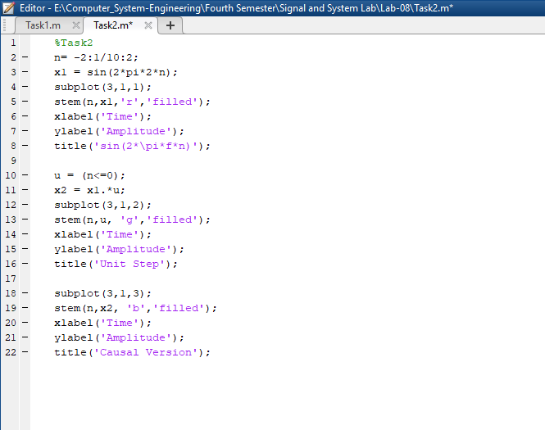

**OUPUT:**

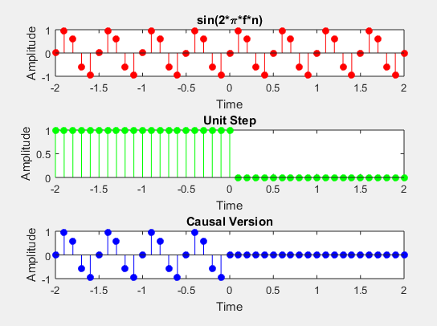

**TASK 03:**

**CODE:**

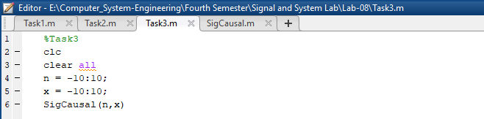

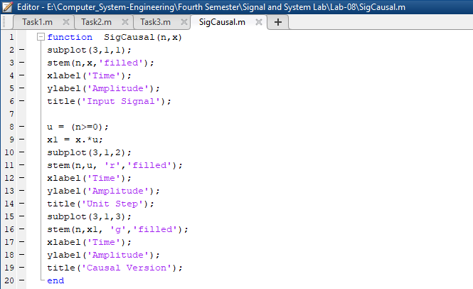

**OUPUT:**

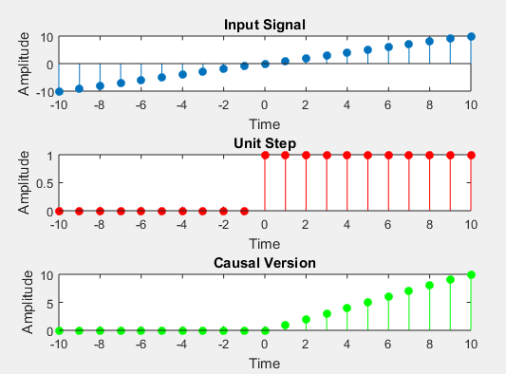

**TASK 04**

**CODE:**

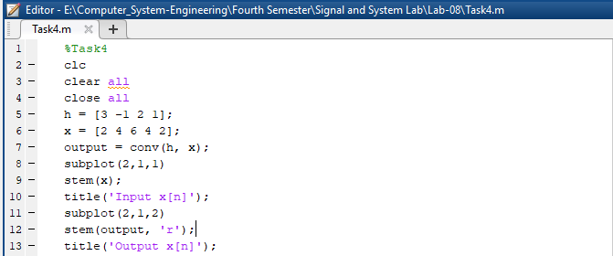

**OUPUT:**

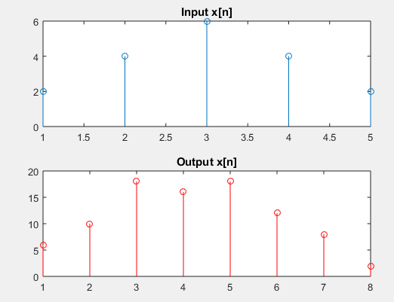

**TASK 05**

**CODE:**

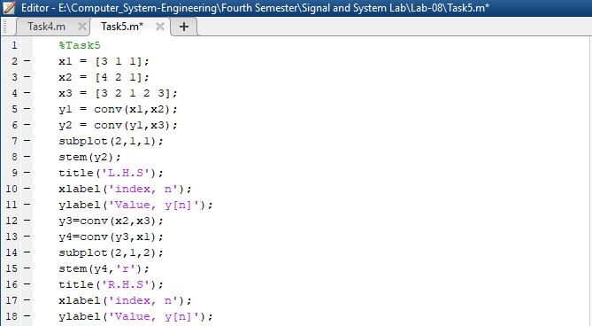

**OUPUT:**

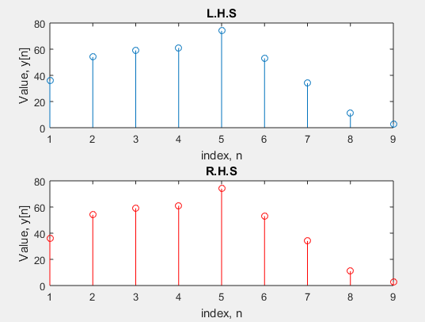

**TASK 06**

**CODE:**

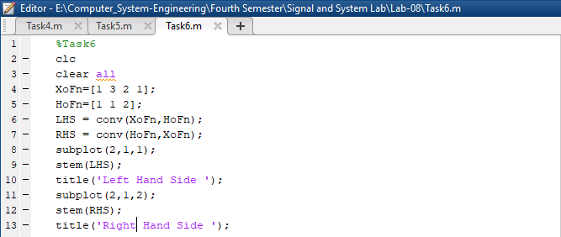

**OUPUT:**

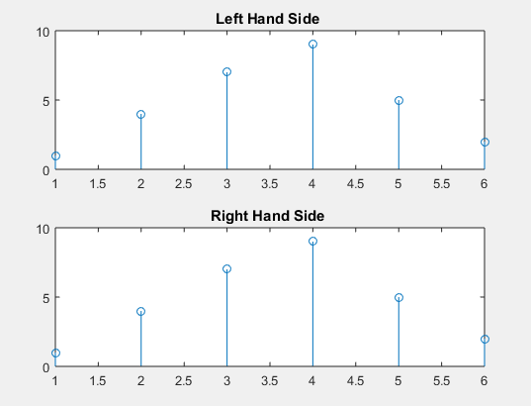

**TASK 07**

**CODE:**

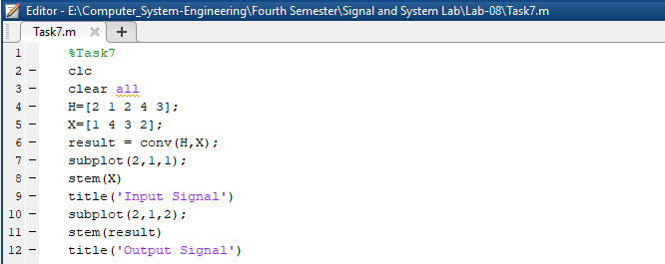

**OUPUT:**

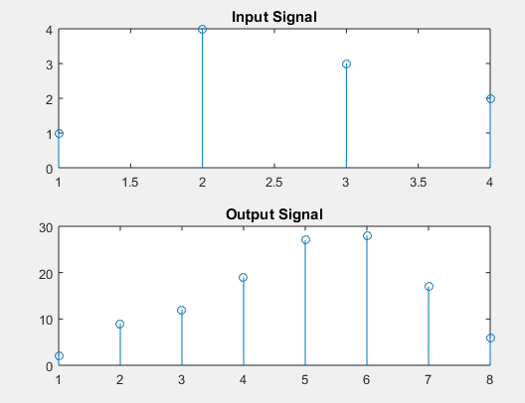

**TASK 08**

**CODE:**

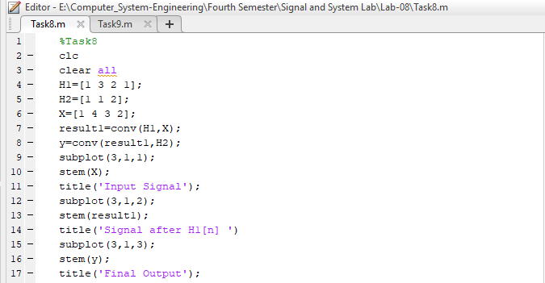

**OUPUT:**

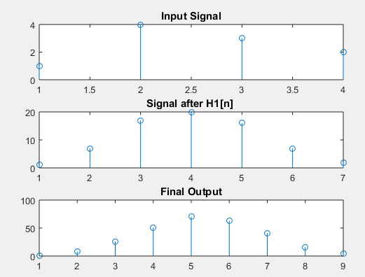

**TASK 09**

**CODE:**

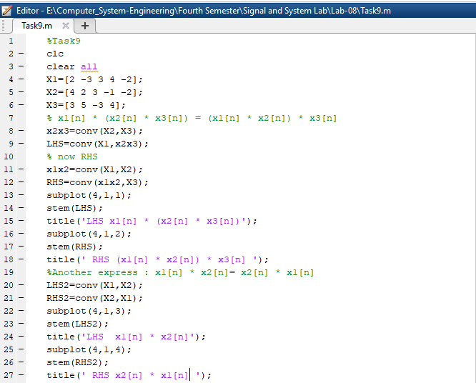

**OUPUT:**

